BamazonCutomer.js

This application takes an SQL database table named products, and provides a user with a list of products they may purchase. The user is prompted to select a product and quantity. If the product and quantity is available, the total purchase amount is calculated for the user and displayed, and the product table quantity for the item purchased is reduced by the purchased quantity.

If the quantity requested is more than what is available, the user is prompted that the quantity is not available, informed of the quantity that is available, and is given another chance to purchase an item.

Initial Mysql Workbench DB and table created with SEED file as noted below:

Seed file run:

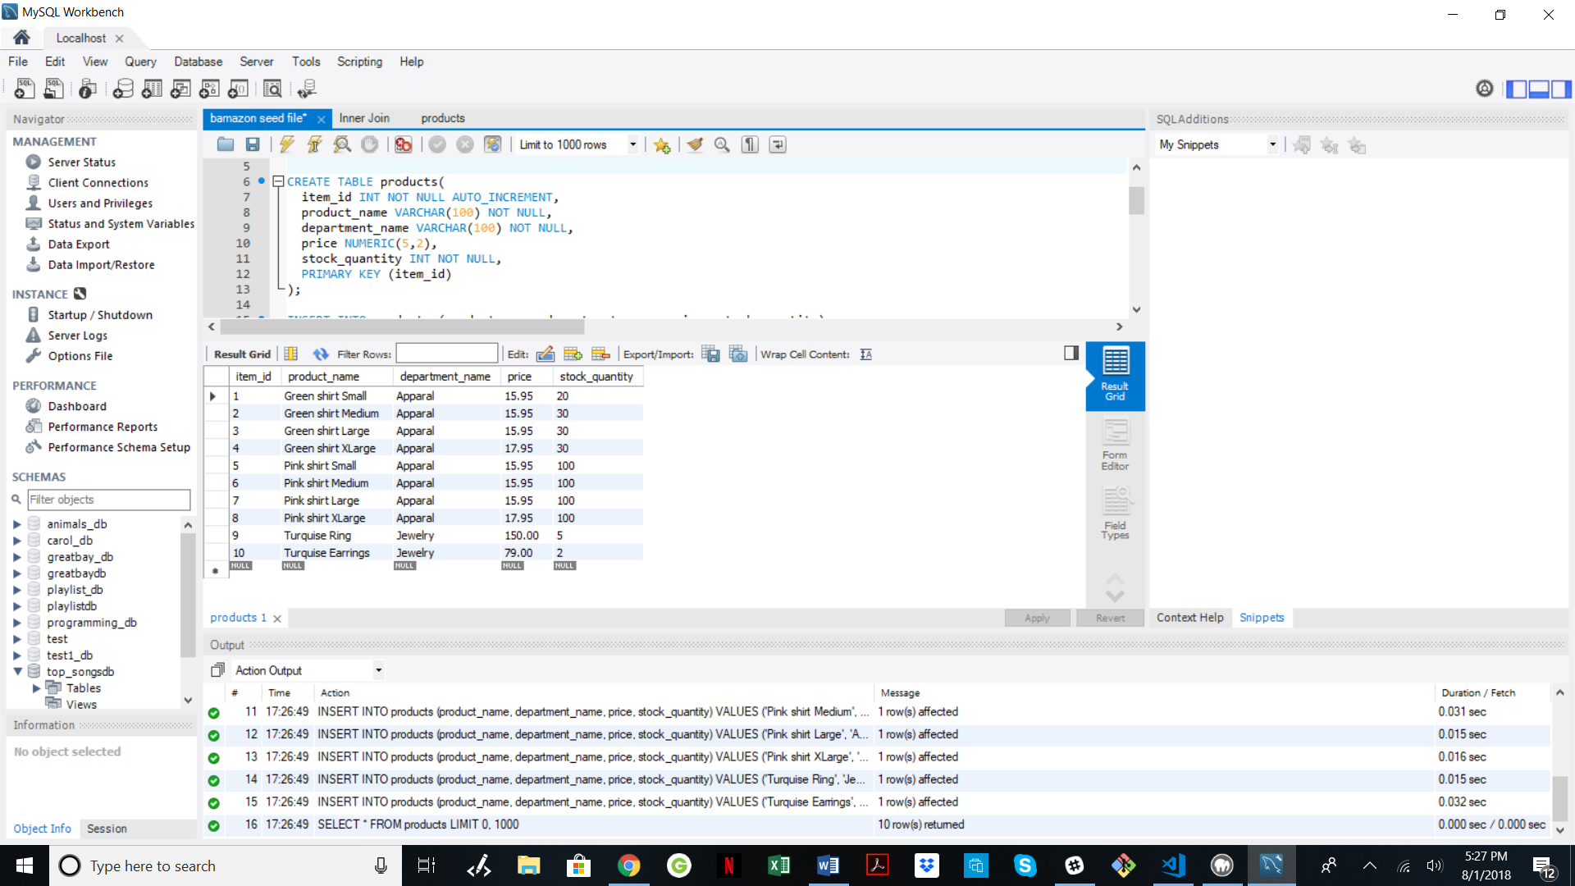

Terminal Output:

User is prompted with 2 questions:

“What Product would you like to buy?”

The user is presented with a list and will scroll to the product number or enter the product number to select a product.

The next question will be:

“How many would you like to buy?”

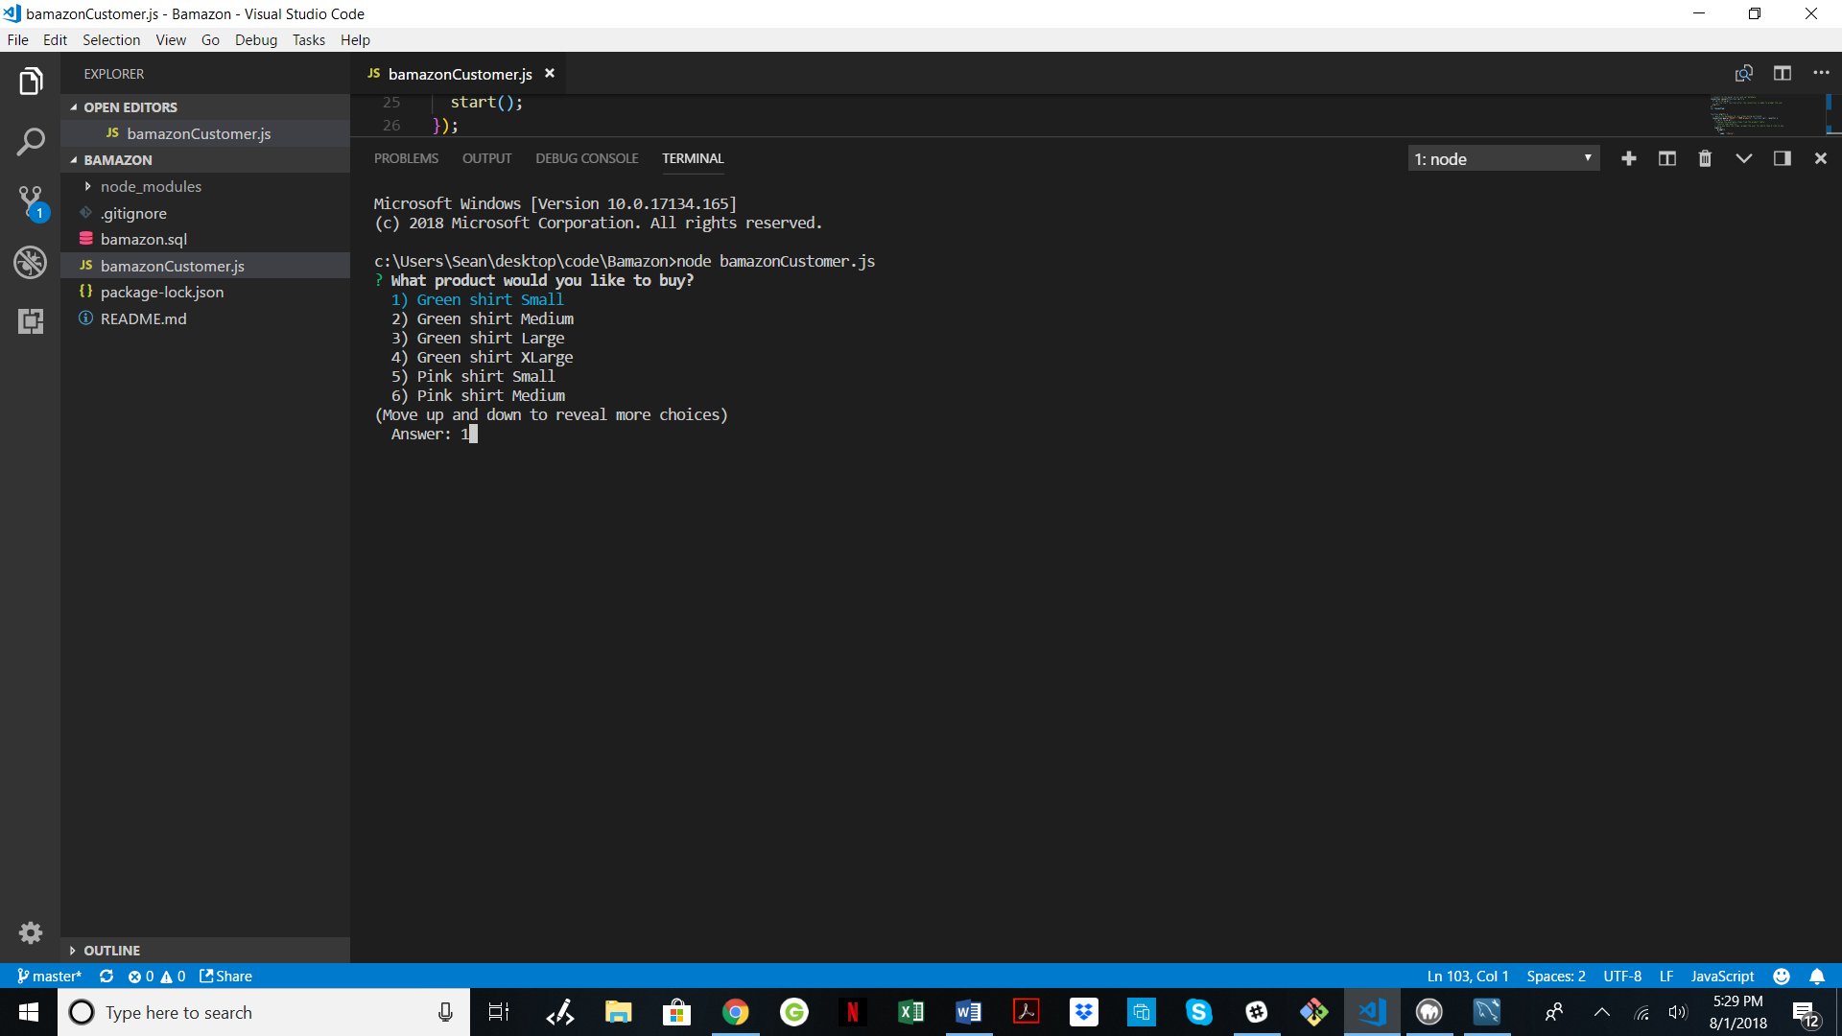

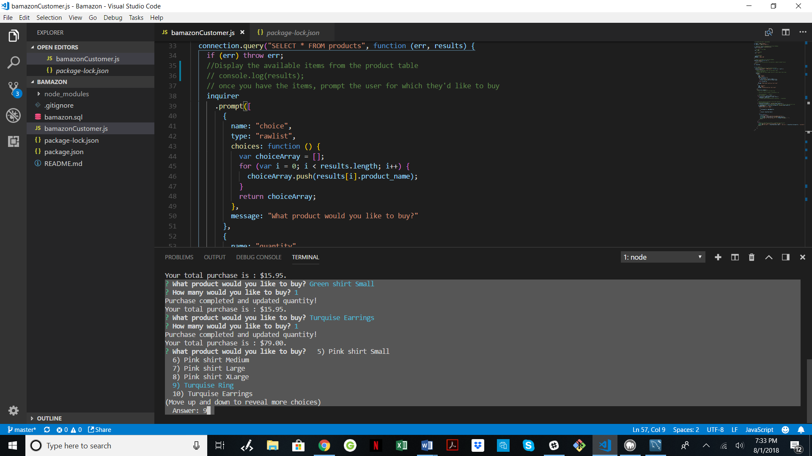

? What product would you like to buy? 5) Pink shirt Small

6) Pink shirt Medium

7) Pink shirt Large

8) Pink shirt XLarge

9) Turquise Ring

10) Turquise Earrings

(Move up and down to reveal more choices)

Answer: 9

When answer 9 is given: the following is displayed:

What product would you like to buy? Turquise Ring

? How many would you like to buy? 500

When asking for purchase of 500 Turquise rings, the following message appears:

Sorry, quantity not available. Try again...

The item, Turquise Ring, has only 5 available.

Screen shots:

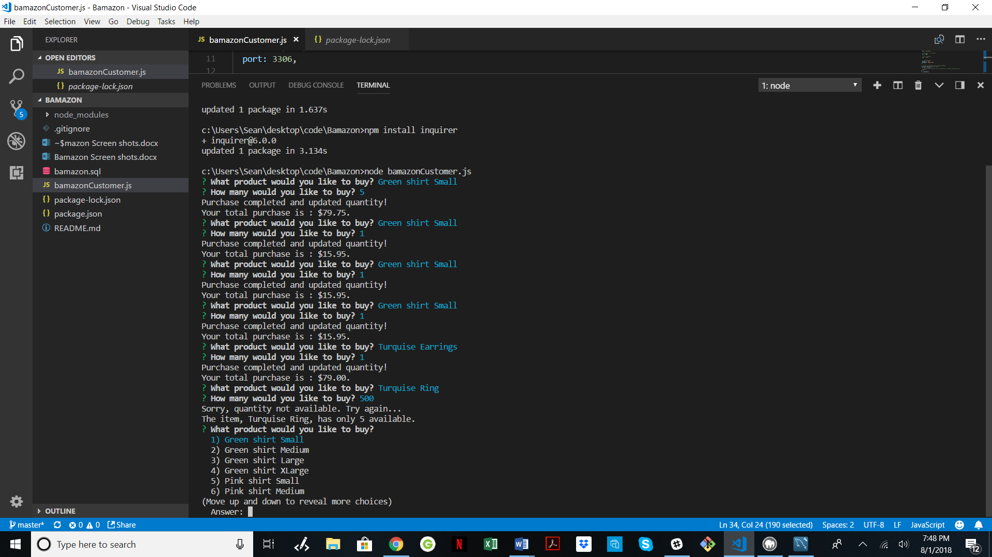

We will purchase 5 turquise rings and this will be accepted:

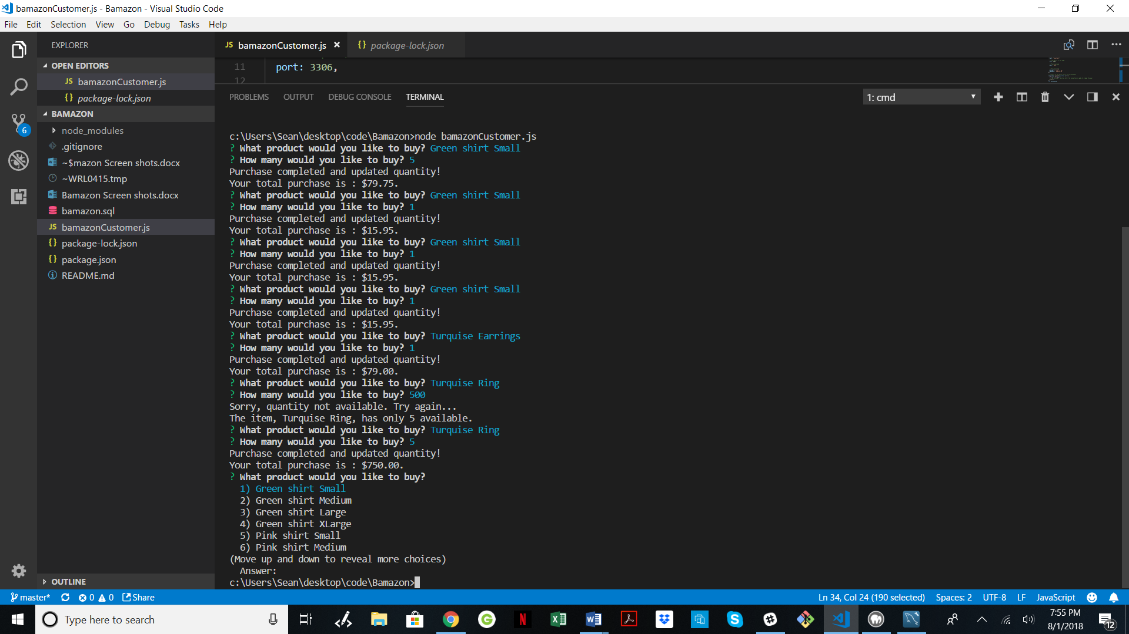

UPDATED TABLE After above purchases:

